**MY RSP SANDBOX JOURNAL**

My Name : Srushti Ravikant Potey

This is all about my journey started and ended in working with RSP Sandbox.

I have completed 2 projects which are:

1. Create a to do list web app.
2. Create a calculator.

Now in to do list app:

I used languages like HTML,CSS,Javacsript.In that I have used some functions in javascript.My snippet of the code are:

HTML:-

I have used this snippet in making list:-

<!DOCTYPE html>

<!-- Created By CodingNepal - www.codingnepalweb.com -->

<html lang="en">

<head>

    <meta charset="UTF-8">

    <meta name="viewport" content="width=device-width, initial-scale=1.0">

    <title>Todo App JavaScript | CodingNepal</title>

    <link rel="stylesheet" href="style1.css">

    <link rel="stylesheet" href="https://cdnjs.cloudflare.com/ajax/libs/font-awesome/5.15.3/css/all.min.css"/>

</head>

<body>

  <div class="wrapper">

    <header>MY TO DO LIST</header>

    <div class="inputField">

      <input type="text" placeholder="Add your new todo">

      <button><i class="fas fa-plus"></i></button>

    </div>

    <ul class="todoList">

      <!-- data are comes from local storage -->

    </ul>

    <div class="footer">

      <span>You have <span class="pendingTasks"></span> pending tasks</span>

      <button>Clear All</button>

    </div>

  </div>

  <script src="script.js"></script>

</body>

</html

CSS:-

@import url('https://fonts.googleapis.com/css2?family=Poppins:wght@200;300;400;500;600;700&display=swap');

*{

  margin: 0;

  padding: 0;

  box-sizing: border-box;

  font-family: 'Poppins', sans-serif;

}

::selection{

  color:black;

  background: rgb(142, 73, 232);

}

body{

  width: 100%;

  height: 100vh;

  /* overflow: hidden; */

  padding: 10px;

  background: linear-gradient(to bottom, #68EACC 0%, #497BE8 100%);

}

.wrapper{

  text-align: center;

  background:white;

  max-width: 400px;

  width: 100%;

  margin: 120px auto;

  padding: 25px;

  border-radius: 5px;

  box-shadow: 0px 10px 15px rgba(0,0,0,0.1);

}

.wrapper header{

    color:black;

  font-size: 30px;

  font-weight: 600;

}

.wrapper .inputField{

  margin: 20px 0;

  width: 100%;

  display: flex;

  height: 45px;

}

.inputField input{

  width: 85%;

  height: 100%;

  outline: none;

  border-radius: 3px;

  border: 1px solid #ccc;

  font-size: 17px;

  padding-left: 15px;

  transition: all 0.3s ease;

}

.inputField input:focus{

  border-color: #8E49E8;

}

.inputField button{

  width: 50px;

  height: 100%;

  border: none;

  color: #fff;

  margin-left: 5px;

  font-size: 21px;

  outline: none;

  background: #8E49E8;

  cursor: pointer;

  border-radius: 3px;

  opacity: 0.6;

  pointer-events: none;

  transition: all 0.3s ease;

}

.inputField button:hover,

.footer button:hover{

  background: #721ce3;

}

.inputField button.active{

  opacity: 1;

  pointer-events: auto;

}

.wrapper .todoList{

  text-align: center;

  max-height: 250px;

  overflow-y: auto;

}

.todoList li{

  position: relative;

  list-style: none;

  margin-bottom: 8px;

  background: #f2f2f2;

  border-radius: 3px;

  padding: 10px 15px;

  cursor: default;

  overflow: hidden;

  word-wrap: break-word;

}

.todoList li .icon{

  position: absolute;

  right: -45px;

  top: 50%;

  transform: translateY(-50%);

  background: #e74c3c;

  width: 45px;

  text-align: center;

  color: #fff;

  padding: 10px 15px;

  border-radius: 0 3px 3px 0;

  cursor: pointer;

  transition: all 0.2s ease;

}

.todoList li:hover .icon{

  right: 0px;

}

.wrapper .footer{

  display: flex;

  width: 100%;

  margin-top: 20px;

  align-items: center;

  justify-content: space-between;

}

.footer button{

  padding: 6px 10px;

  border-radius: 3px;

  border: none;

  outline: none;

  color: #fff;

  font-weight: 400;

  font-size: 16px;

  margin-left: 5px;

  background: #8E49E8;

  cursor: pointer;

  user-select: none;

  opacity: 0.6;

  pointer-events: none;

  transition: all 0.3s ease;

}

.footer button.active{

  opacity: 1;

  pointer-events: auto;

}

JS:-

// getting all required elements

const inputBox = document.querySelector(".inputField input");

const addBtn = document.querySelector(".inputField button");

const todoList = document.querySelector(".todoList");

const deleteAllBtn = document.querySelector(".footer button");

// onkeyup event

inputBox.onkeyup = ()=>{

  let userEnteredValue = inputBox.value; //getting user entered value

  if(userEnteredValue.trim() != 0){ //if the user value isn't only spaces

    addBtn.classList.add("active"); //active the add button

  }else{

    addBtn.classList.remove("active"); //unactive the add button

  }

}

showTasks(); //calling showTask function

addBtn.onclick = ()=>{ //when user click on plus icon button

  let userEnteredValue = inputBox.value; //getting input field value

  let getLocalStorageData = localStorage.getItem("New Todo"); //getting localstorage

  if(getLocalStorageData == null){ //if localstorage has no data

    listArray = []; //create a blank array

  }else{

    listArray = JSON.parse(getLocalStorageData);  //transforming json string into a js object

  }

  listArray.push(userEnteredValue); //pushing or adding new value in array

  localStorage.setItem("New Todo", JSON.stringify(listArray)); //transforming js object into a json string

  showTasks(); //calling showTask function

  addBtn.classList.remove("active"); //unactive the add button once the task added

}

function showTasks(){

  let getLocalStorageData = localStorage.getItem("New Todo");

  if(getLocalStorageData == null){

    listArray = [];

  }else{

    listArray = JSON.parse(getLocalStorageData);

  }

  const pendingTasksNumb = document.querySelector(".pendingTasks");

  pendingTasksNumb.textContent = listArray.length; //passing the array length in pendingtask

  if(listArray.length > 0){ //if array length is greater than 0

    deleteAllBtn.classList.add("active"); //active the delete button

  }else{

    deleteAllBtn.classList.remove("active"); //unactive the delete button

  }

  let newLiTag = "";

  listArray.forEach((element, index) => {

    newLiTag += `<li>${element}<span class="icon" onclick="deleteTask(${index})"><i class="fas fa-trash"></i></span></li>`;

  });

  todoList.innerHTML = newLiTag; //adding new li tag inside ul tag

  inputBox.value = ""; //once task added leave the input field blank

}

// delete task function

function deleteTask(index){

  let getLocalStorageData = localStorage.getItem("New Todo");

  listArray = JSON.parse(getLocalStorageData);

  listArray.splice(index, 1); //delete or remove the li

  localStorage.setItem("New Todo", JSON.stringify(listArray));

  showTasks(); //call the showTasks function

}

// delete all tasks function

deleteAllBtn.onclick = ()=>{

  listArray = []; //empty the array

  localStorage.setItem("New Todo", JSON.stringify(listArray)); //set the item in localstorage

  showTasks(); //call the showTasks function

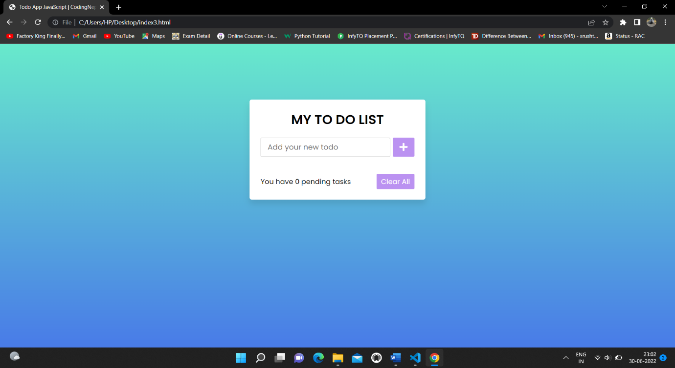

]

OUTPUT:-

So in calculator:-

I have used languages HTML,CSS .

My snippet of code is :-

HTML:-

<!DOCTYPE html>

<!-- Created By CodingNepal -->

<html lang="en" dir="ltr">

   <head>

      <meta charset="utf-8">

      <!-- Somehow I got an error, so I comment the title, just uncomment to show -->

      <!-- <title>Calculator</title> -->

      <link rel="stylesheet" href="style2.css">

      <script src="https://code.jquery.com/jquery-3.4.1.js"></script>

   </head>

   <body>

      <div class="center">

         <form name="forms">

            <input type="text" id="display" name="display" disabled>

            <div class="buttons">

               <input type="button" id="seven" value="7">

               <input type="button" id="eight" value="8">

               <input type="button" id="nine" value="9">

               <input type="button" id="divide" value="/"><br>

               <input type="button" id="four" value="4">

               <input type="button" id="five" value="5">

               <input type="button" id="six" value="6">

               <input type="button" id="multi" value="*"><br>

               <input type="button" id="one" value="1">

               <input type="button" id="two" value="2">

               <input type="button" id="three" value="3">

               <input type="button" id="subs" value="-"><br>

               <input type="button" id="dot" value=".">

               <input type="button" id="zero" value="0">

               <input type="button" id="add" value="+">

               <input type="button" id="clear" value="C"><br>

               <input type="button" id="equal" value="=">

            </div>

         </form>

      </div>

      <script>

         $(document).ready(function(){

           $('#one').click(function(){

             document.forms.display.value += 1;

           });

           $('#two').click(function(){

             document.forms.display.value += 2;

           });

           $('#three').click(function(){

             document.forms.display.value += 3;

           });

           $('#four').click(function(){

             document.forms.display.value += 4;

           });

           $('#five').click(function(){

             document.forms.display.value += 5;

           });

           $('#six').click(function(){

             document.forms.display.value += 6;

           });

           $('#seven').click(function(){

             document.forms.display.value += 7;

           });

           $('#eight').click(function(){

             document.forms.display.value += 8;

           });

           $('#nine').click(function(){

             document.forms.display.value += 9;

           });

           $('#zero').click(function(){

             document.forms.display.value += 0;

           });

           $('#add').click(function(){

             document.forms.display.value += '+';

           });

           $('#subs').click(function(){

             document.forms.display.value += '-';

           });

           $('#multi').click(function(){

             document.forms.display.value += '*';

           });

           $('#divide').click(function(){

             document.forms.display.value += '/';

           });

           $('#dot').click(function(){

             document.forms.display.value += '.';

           });

           $('#equal').click(function(){

             if (display.value == "") {

               alert("Please enter any numbers to calculate!");

             }else{

               document.forms.display.value =

               eval(document.forms.display.value);

             }

           });

           $('#clear').click(function(){

             document.forms.display.value = "";

           });

         })

      </script>

   </body>

</html>

CSS:-

*{

  margin: 0;

  padding: 0;

  outline: none;

  box-sizing: border-box;

}

body{

  font-family: montserrat;

  display: flex;

  text-align: center;

  justify-content: center;

  align-items: center;

  min-height: 100vh;

  background: linear-gradient(#9cebfc,#6ae1fb);

}

.center{

  /* display: none; */

  width: 350px;

  background: black;

  border-radius: 20px;

}

input[type="text"]{

  height: 60px;

  width: 300px;

  margin-top: 40px;

  border-radius: 1px;

  border: 1px solid #e1e7ea;

  color: black;

  font-size: 22px;

  font-weight: bold;

  text-align: right;

  padding-right: 20px;

  background: linear-gradient(#d1dce0,#dfe6e9);

}

form .buttons{

  width: 300px;

  margin: 10px 25px 0 25px;

  padding: 10px 0;

}

input[type="button"]{

  width: 58px;

  height: 55px;

  margin: 5px;

  font-size: 22px;

  line-height: 55px;

  border-radius: 3px;

  border: 1px solid #d9d9d9;

  background: linear-gradient(#d9d9d9, #bfbfbf);

}

input[type="button"]:hover{

  transition: .5s;

  background: linear-gradient(#bfbfbf, #d9d9d9);

}

input#clear{

  background: #ff1a1a;

  border: 1px solid #cc0000;

  color: white;

}

input#equal{

  width: 275px;

  margin: 10px 0 10px 0;

  font-size: 30px;

  color: white;

  background: #ff3d00;

  border: 1px solid #b32a00;

}

OUTPUT:-

